**APS1052 - FINAL PROJECT REPORT**

***Netflix Stock Price Prediction Analysis***

**Professor:** Sabatino Costanzo & Loren Trigo

**Term:** Fall 2022

Submitted by/before: December 21, 2022

**Team Members**

Athira Indrakumar - 1008653976

Emerald Ekong - 1002451269

Vishnu Priya Rajendran - 1008640160

**EXECUTIVE SUMMARY**

The primary objective of this research is to predict stock prices of Netflix for analyzing profit on day closing. The research predicts the stock market as profit in the form of a chart using Python. The attributes included in the model are Date, Open, Close, High, Low, Volume and Adj Close. The profits of various years are calculated and shown in the form of graphs. The data collected from 2015 to 2019 are used, and it is divided into two parts - training set as 80% and testing set as 20 %. The dataset is named NFLX.csv in the folder. We are using the LSTM model to forecast the index. Final prediction is done in the testing part only. We are using model metrics like White Reality check, SMA and MACD to evaluate the model.

**RESULTS:**

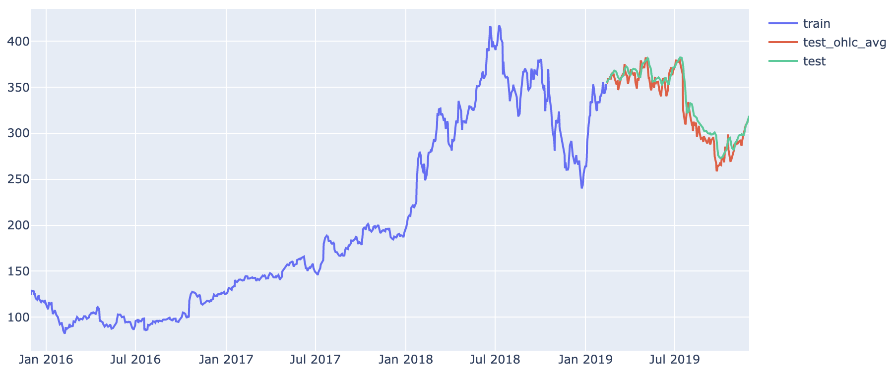

**Fig:1.1 (Prediction)**

* Total Annual Return in percent = 9.084915
* CAGR in percent = 8.042212
* Sharpe Ratio = 0.480000
* Average return -0.002097
* Average Return Range: [-0.00433821 0.00405262]
* P_value: 0.8256

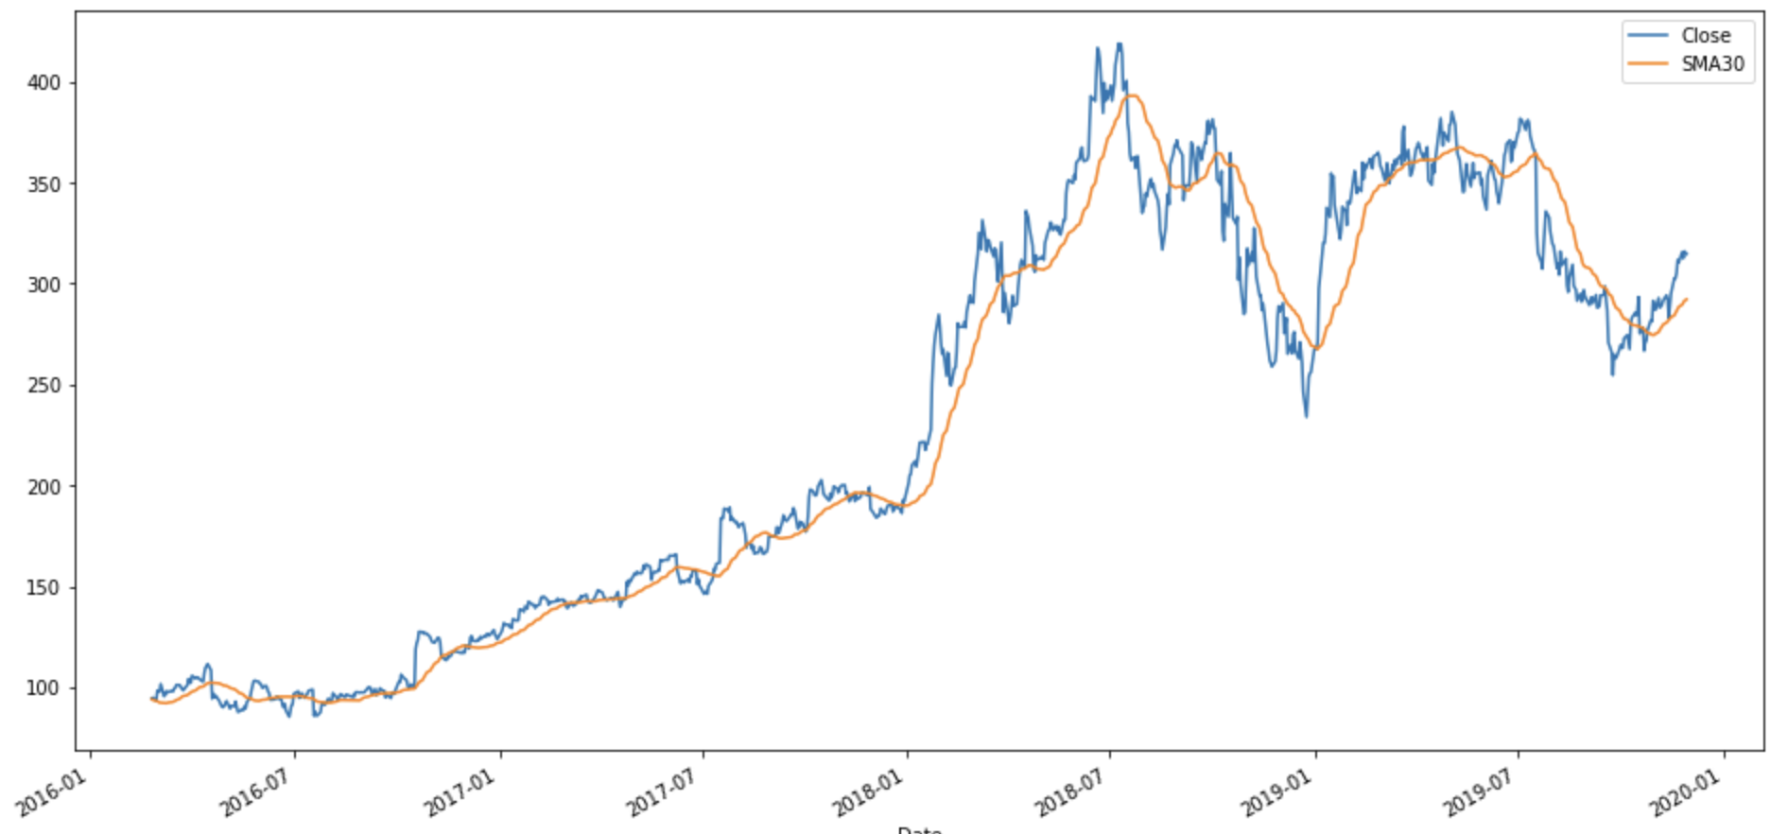

**Fig:1.2 (SMA)**

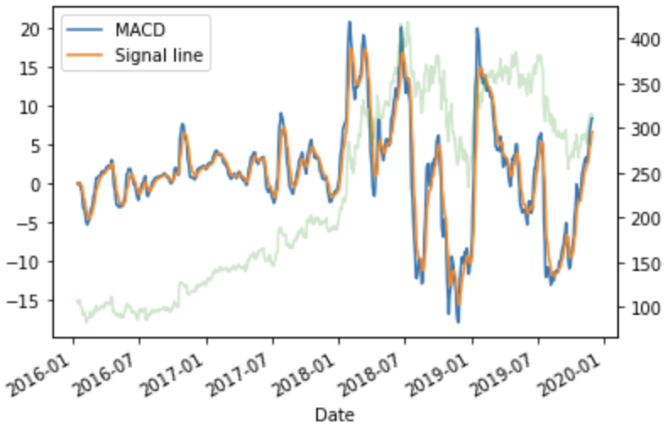

**Fig:1.3 (MACD)**